

SUPPORT GROUPS at ROSEBURN
We run a variety of groups at Roseburn to support children with their learning. They target different ages and stages of development and a variety of support needs. If you would like to discuss these groups further or have any questions please contact:
Jacqui Gardner ASL Coordinator or Jan McColl ASL teacher

The team of PSAs who work at Roseburn and help to deliver many of these programmes are:
Tim Parkinson, Eleanor McLean, Lorraine Hussain, Val Glasgow, Belinda Dreze, Dorothy Brown, Manuel Munoz, Ruhi Singhal, Lynn Deane



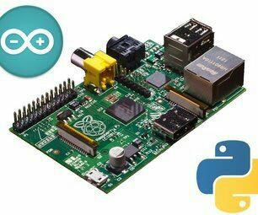
CODING This group introduces children to the Raspberry Pi and the programmes Python and Scratch which teach children computational thinking, coding and the language required to programme. They will work together on animation or electronics projects, communicating and problem solving. The Raspberry Pi is a capable little computer which can be used in electronics projects, and for many of the things that a desktop PC does. For further information www.codeclub.org.uk
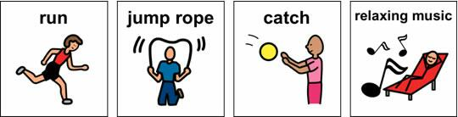
TIP Therapy Inclusion Project
This group use games, physical activity and discussion to develop balance, coordination, social communication, literacy, listening and talking, fine motor skills, independence and confidence. For further information www.asl.scot.nhs.uk TIP leaflet
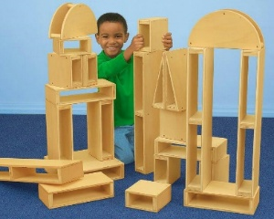
BLOCK PLAY
A group of children need to communicate, collaborate and problem solve using thinking skills and creativity to build structures using large blocks. This could be linked to topics or from own ideas and suggestions. These ideas can also be developed using Loose Parts Play materials in the playground.

FINE MOTOR SKILLS
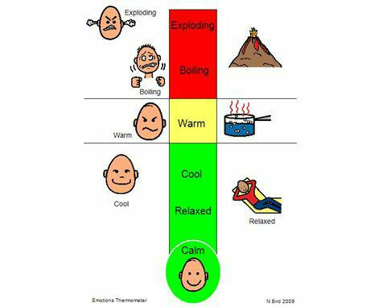
This group develops hand eye coordination, manipulation, dexterity, handwriting and could include drawing, cutting, threading, buttons, weaving crafts, paper folding-origami type tasks.
EMOTION TALKS
We know that children cannot learn when they are in heightened emotional states. Moreover it is part of the Health and Wellbeing Curriculum to support children to manage their emotions and improve mental health for young people in our country. Emotion Talks supports children in communicating and dealing with their emotions in a constructive way, giving them tools for life. Emotion Talks is a resource that supports the development of children and young people’s emotional understanding. Using chat boards and picture cues children are helped to recognise and understand triggers for their emotions, as well as improving their ability to talk about them they will develop strategies to deal with them appropriately.

TALK & MOVE
Children work in small groups to complete a series of fun games and activities developing listening, talking, turn taking, cooperation and social communication skills.

EAL English as an Additional Language
We value the diversity of languages and cultures at Roseburn. Bilingual and multi-ethnic children and families may be supported by an English as an additional language teacher or bilingual support assistant who speaks their home language. Translators can be organised for parent teacher consultations or child planning meetings.
DYSLEXIA SUPPORT
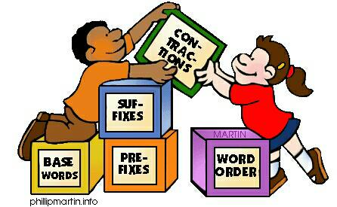
The ASL teacher and a Pupil Support Assistant follow an intense programme of activities to support children with difficulties in literacy. These help develop strategies for spelling, reading, writing and organisation.
LITERACY SUPPORT
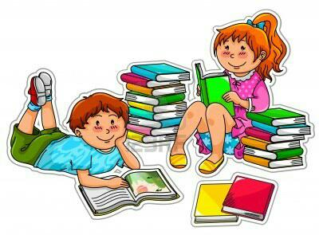
The ASL teacher supports both in class and with small reading, spelling and writing groups. Assessments are carried out and advice and resources are given to class teachers for children with specific difficulties. Pupil Support Assistants also support literacy work in classes.
PAIRED READING
We have volunteers from Anderson Strathearn working with children to promote reading for enjoyment. They kindly donate an hour a week, to read with children and share books, discussing characters, setting and plot.
READ, WRITE, INC.
Read Write Inc. (RWI) is a phonics based programme, which helps children learn to read and write while also developing a wide range of vocabulary and encouraging a love of stories.
How will it work.
- Regular RWI lessons each week with a teacher or PSA

- Learners work with a partner
- Learners are taught to read and write the letter sounds
- Learners are taught to read and write words using ‘Fred Talk’
- Regular reading of lively stories featuring words they have learned to sound out
- Lots of discussion about the stories
- Writing activities which make strong links between reading, writing, spelling and grammar
- Successes are regularly recognised and celebrated
Children can be supported at home by practising the sounds, red and green words and talking about the stories. For further information: www.ruthmiskinliteracy.com

SOCIAL THINKING
Social Thinking focuses on helping children figure out how to think in social situations. Children are taught to observe and think about their own and others’ thoughts and feelings. They also learn the connection between thoughts, feelings and behaviours.
The idea is that children need to develop social “thinking” before they can use social “skills.” The focus on thinking can help children understand how to interact more effectively with others.
Who It’s For
Social Thinking is designed for ages 4 through adult. The teaching framework is geared for people with average to above average language and cognitive skills. Its concepts and strategies are used to help with:
Social learning and attention issues.
Trouble picking up on social cues such as facial expressions and body language.
Difficulty listening or working in a group.
How It Works
Typically, our groups are around 4 children (P5- P7) with weekly 45 – 60 minute group session for 6-8 weeks.
Social Thinking materials break down social concepts and so adults can convey them in ways that make sense to children. For example, children aren’t simply told to “make eye contact.” Instead, they learn about “thinking with your eyes”—that people’s eyes are sources of information. By following someone’s eyes, children can get “clues” about what that person is thinking or might do next.
Children will work on other social concepts, too. They may learn how to figure out and follow the group plan and about whether their body and brain are in sync or out of sync with the group. They may learn about making a smart guess or figuring out the “hidden rules” and what is expected or unexpected behaviour.
Once children are taught these concepts, they learn how to apply them to different situations. The programme will be delivered through direct teaching, role-play, videos and fun in the context of an encouraging group.
For more information on Social Thinking go to www.socialthinking.com

MATHS & NUMERACY SUPPORT

Pupil Support Assistants work in classes with groups of children or individuals who may need support with aspects of maths or number work. They will be using the mental agility guidelines, practical equipment and SEAL (staged early arithmetic learning) strategies

We are also lucky to be supported by the
ASL Team leader for NW Edinburgh Sarah Neary,
Educational Psychologist Alan Jones,
Speech and Language Therapists Caitlin Doig and Nikki Kerr,
Active Schools Coordinator Neil Russell
and a range of medical professionals, occupational therapists, physiotherapists and family support workers.
Strong links with parents, professionals and our young people are essential to ensure they are safe, healthy, active, nurtured, achieving, responsible, respected and included in their education.

