Primary 5 & Primary 4/5 Home learning project 2020.

Throughout this year both classes have been working in partnership with ‘Earth Calling’ to achieve their John Muir award.
We have been working very hard during our wildlife Rangers expeditions and in school. Both Mrs Scott and Mr Carson would like to encourage all pupils and their families to take part in the following project to still achieve their award this year.
If/once you complete any part of the project please share with your class on the parental whatsapp group (this is a lovely way to keep everyone connected), or the school twitter page or email us on Admin@Roseburn.edin.sch.uk and we can share your achievements.
Thank you,
Mrs Scott & Mr Carson

What is the John Muir award?
The John Muir award challenges you to do the following things;
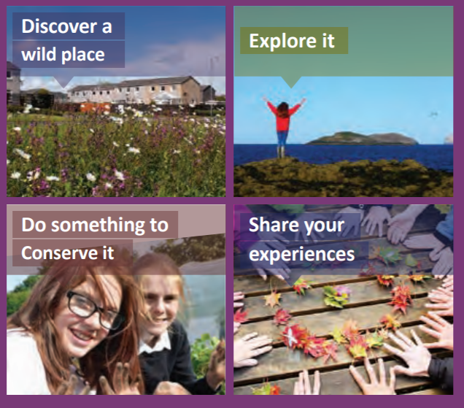

The John Muir Award is an environmental award scheme focused on wild places. It supports people to connect with, enjoy and care for nature, landscape, and the natural environment. It’s for people of all backgrounds and ages – groups, families and individuals.
Its name comes from John Muir, the Scots-born conservation pioneer known as ‘the founding father of National Parks’, this can also be linked to our Famous Scots topic. It was launched in 1997 by the John Muir Trust, which was formed in 1983 to safeguard and conserve wild places in the United Kingdom.
So far this year we have; (please recreate these if you want to)
- Discovered and explored our local area, the ‘Water of Leith’.
- Created mandalas using Autumn resources found around the local area.
- Built bird nests and identified what types of birds would use them.
- Discovered different habitats and bugs around the area.
- Identified & tasted wild garlic, few flowered leek and other edible ‘wild’ plants. (Please do not do this at home as some things look the same but could be poisonous).
- Collected and created art with a range of ‘fungi’ found in the area.
- Discovered and learnt about native & invasive weeds found in Scotland.
- Created and conserved our own national parks in the local area and explained the need to protect these.
Here are a range of cross curricular activities that you could try at home;
(These are just a suggestion & if you have anything else in mind please do give it a go).
Writing tasks
This term we have been learning about famous Scots. John Muir comes into that category as he was born in Dunbar, Scotland. You could research facts about his life and describe how he has had an impact on our world as we know it. You can present your writing as a fact file, timeline, story of events or even write a diary entry as John Muir himself.
Art
John Muir was captured by the natural beauty of our world. You could sketch a picture of a natural landscape you visit or even use a picture for inspiration. One of John’s favourite places was Yosemite National Park in California.
Choose any ‘wild’ plant or animal that can be found in your local area and label their features and what makes them unique.
Recreate anything that we have done so far, you could make a bird nest in your garden or create another mandala using leaves, moss, grass etc.
Health & Wellbeing
There is nothing more important that looking after your own mental health. Exploring or going for a walk outdoors is something that encourages mindfulness.
From 20th March 2020 the National Trust have agreed to remove all pay barriers from National Trust parks and Gardens. This is in response to support social distancing and the need to be outside in nature for our own mental wellbeing. It will mean that all the grounds behind pay barriers will be open for everyone and carparking chargers removed so you can enjoy open space and keep your social distance. All cafes, houses, retail and events will be closed so please bring a flask and a sandwich to enjoy.
ICT
Create a power point presentation about the John Muir award and what we have completed in wildlife rangers so far. Remember to find pictures online of the variety of living things we have discovered.
Research a national park of your choice online and discover how the John Muir trust focus on conserving the wildlife and plants within the area.

Conserve
Something that has started to grow along the Water of Leith and Corstophine Hill is an invasive weed called Himalayan Balsam. This is a growing problem in these small woodland areas because it is preventing other species of plants from growing.
Research what it looks like, where it originally comes from and what we can do to help conserve these local areas. Maybe you might spot some on a walk and remove it?
If you spot it make sure to remove it correctly (remove from roots and place into a plie – do not stamp on it as this will release seeds).
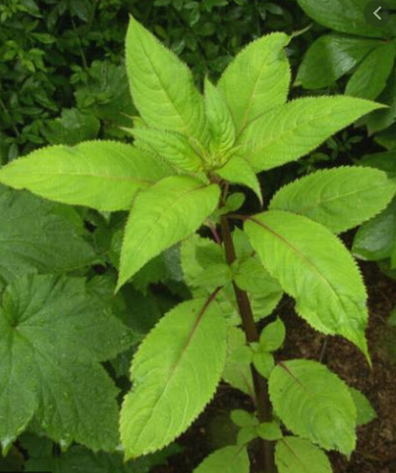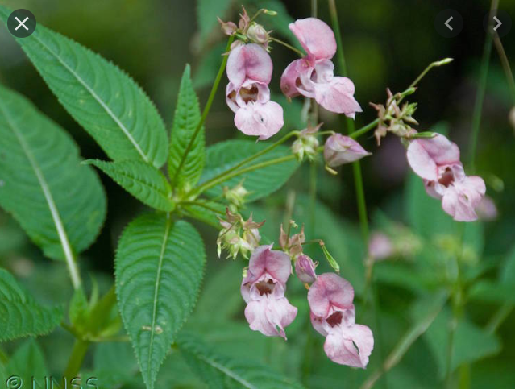
Himalayan balsam flowers from June to October. It is pollinated by bumble-bees. Seeds are set from August to October. There are 4-16 seeds per pod and each plant can produce 800 seeds.
Share your experiences
Please remember to share anything you complete in this project with us. We will put all your pictures, pieces of writing and artwork into our online log. Once all this information has been collated we can send it off for the approval for our award. Please do not hesitate to get in touch with any questions or helpful ideas/resources. More information can be found by following the link below.
https://www.johnmuirtrust.org/john-muir-award

