Roseburn Nursery
Learning Focus: Jack and the Bean Stalk
Date: 16.3.20 Source: e.g. child interest/loose long term
Links to wider Es & Os:

Literacy: I enjoy exploring and playing with the patterns and sounds of language, and can use what I learn. LIT 0-01a / LIT 0-11a / LIT 0-20a

Numeracy: I am developing a sense of size and amount by observing, exploring, using and communicating with others about things in the world around me MNU 0-01a

Science: I have helped to grow plants and can name their basic parts. I can talk about how they grow and what I need to do to look after them. SCN 0-03a

Expressive arts: I have the freedom to use my voice, musical instruments and music technology to discover and enjoy playing with sound and rhythm. EXA 0-17a

Building the Ambition:
Communication: I am learning to take part in verbal games, and learning familiar rhymes and songs.

Maths and early numeracy: I am learning to match objects 1:1.

Science: I enjoy taking part in planting activities and am learning about that plants need to grow.

Music: I am exploring how to play simple percussion instruments and clap along
Learning experiences:  Explore the story of Jack and the Bean Stalk through books, props, puppets and interactive activities.  https://www.youtube.com/watch?v=W5rxfLRgXRE  Explore musical instruments and rhythm when learning new Jack and the Bean Stalk songs https://www.bbc.co.uk/programmes/articles /5qCfgK9MTlHyTP67JgxC2vM/jack-and-the-beanstalk-1-what-shall-we-do - online tutorial breaks down song and how children can learn it.  Explore harp music linking to different instruments from story https://www.youtube.com/watch?v=7TO_oHxuk6c  Questioning – Can the children answer key questions about the story? E.g. Would the giant be angry? What could Jack say to explain why he took the things? Would Jack offer to return them? Could Jack outwit the giant? Do you think Jack did the right thing to sell the cow for five beans after all?  Planting and Growing- introduction of Spring.  Planting beans in soil and glass jars to explore different parts of a plant and what they need to survive.  STEM challenge – Can you build your own bean stalk? How tall can you make it?  Can you plant your own bean at home? How tall will it grow? | Observation focus/assessment  Say Make Write Do:  Share story at group story time, group time and 1:1, props available across playrooms,  https://www.bbc.co.uk/teach/school-radio/english-ks1-jack-and-the-beanstalk-index/zn9hxyc  explore different sections of the story during small group time. Pausing for questions about how characters feel? What might happen next? What would you do?  Children can identify repeated rhythms and patterns in music and songs.  Can independently tap or clap out a beat from music, staff or video.  Children can answer questions about the story, make predictions about the text. Create their own questions to ask another group.  Beans planted at group time. Explore images *

Stages of growth of a bean plant
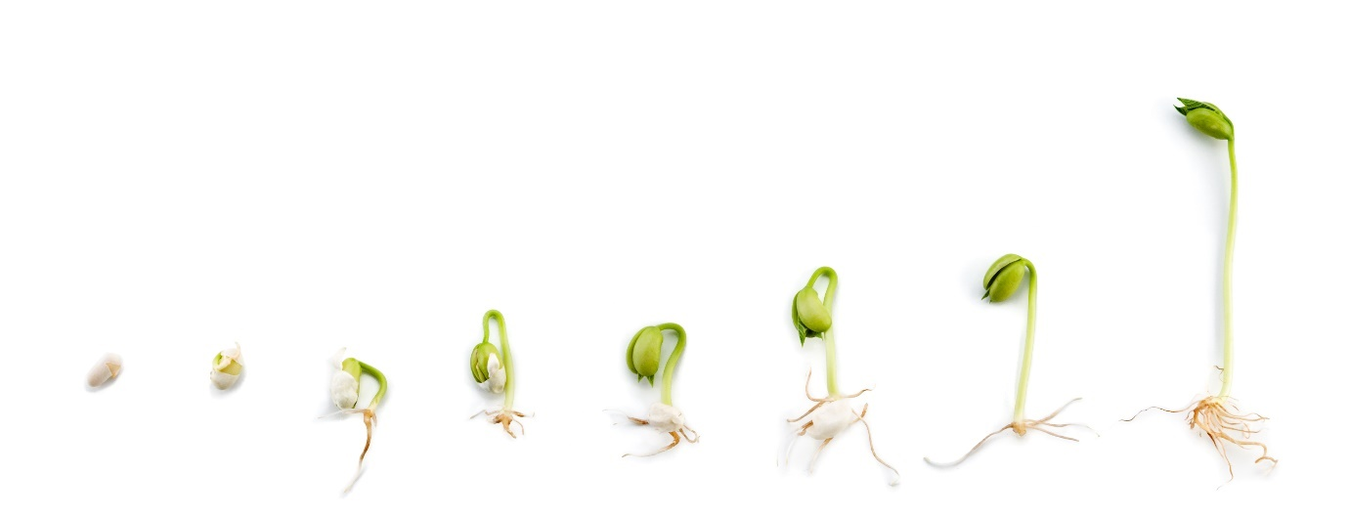
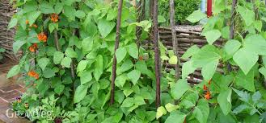 Bean plant
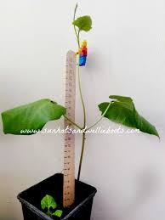 how to measure and support plant
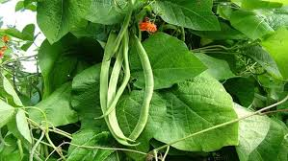 beans

