

Roseburn Nursery
Home Learning and Learning Through Play Opportunities
Week Beginning 18.5.20

This learning grid will hopefully offer you some ideas and activities you could do at home with your child during the school closure. Each week we aim to email you a selection of activities that you may wish to do. Please let us know what you think, or if there is anything different you would like. We are missing seeing you all, so please keep in touch. You can upload photos to your Online Learning Journals.
Top Tips:
.
- Allow lots of opportunities for your child to enjoy free play with their toys, following their interests. Use this opportunity to observe what motivates your child and consider different ways you could develop their own interests
- Only offer challenges or play opportunities for as long as they are enjoyable - this might be 15 minutes. You can always go back to them at any time

Literacy  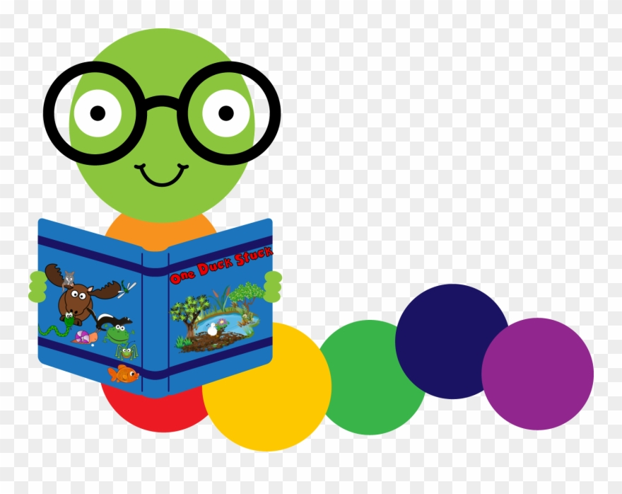 | Maths/ Numeracy  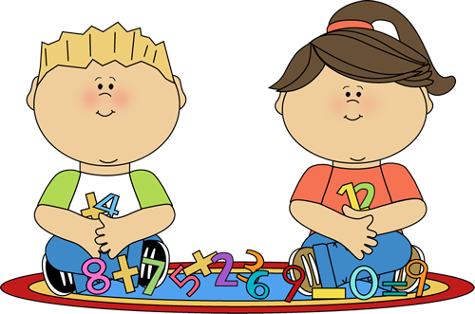 | Health and Wellbeing | Expressive Arts   | Social Studies and Sciences | Website/ App of the week
Our Literacy focus is all about FISH  Here is a nursery favourite.  The Rainbow Fish by Marcus Pfister  https://www.youtube.com/watch?v=QFORvXhub28  Please see an attached rainbow fish pencil control activity.  The book explores friendship. Try this letter writing activity to stay in touch with friends  https://stagedinterventionhighland.files.wordpress.com/2020/04/lets-write-a-letter.pdf | Look at the underwater counting sheet that has also been attached. Can you do some very careful counting of the sea creatures.  Fish have scales and scales are patterns. Can you create your own fish with a repeating pattern of scales – look at the art activity which uses celery to print. | ‘Expect the Unexpected’ is our Building Resilience Topic. This week we are still looking at change but finding ways to cope with change.  This week Skipper needs a new boat to cope with the river of life. Can you try to build/ make him a boat so he can stay afloat.   | We love to sing this song in nursery  https://www.youtube.com/watch?v=gM7uO4WyE-8  Some art activities including celery printing and cutting paper plates  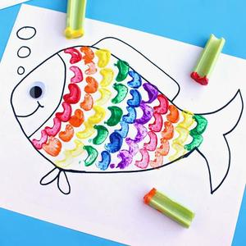  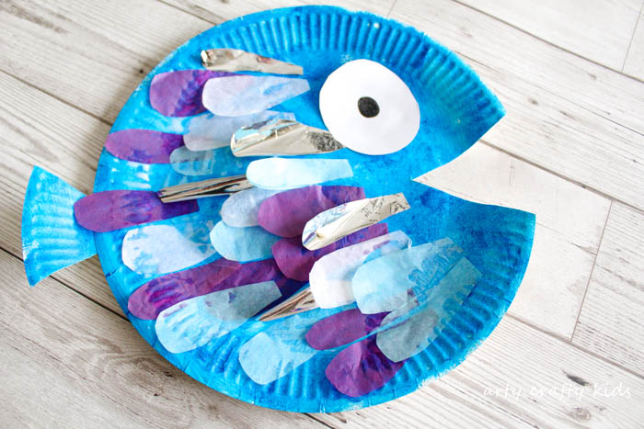 | The following link will take you to BBC Bitesize where you can find out about lots of different fish!  https://www.bbc.co.uk/bitesize/topics/z6882hv/articles/zxgq2hv   | 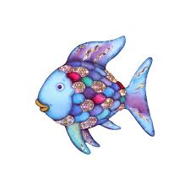  https://www.topmarks.co.uk/learning-to-count/underwater-counting

