Ethos    - HT Meetings  - SFL Meetings  - Lead Teachers (1+2, Digital, L+T)  - Shared Events – ‘Coorie- In’, P7 Camp  - Rights Respecting Schools – sharing practice | Craigmount Cluster  ‘They are all our children’ |  |  |  |  |  | Transition    - P7 – S1  - Enhanced transition  - Building Relationships  - Opportunities  - Review/Develop  - JASS  - School Counsellor  - 2 x Transition Teachers  - 2 X PSO posts (Temp)
 | 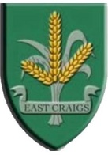 |  | 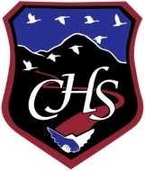 | 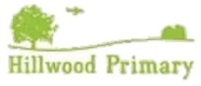 |  | 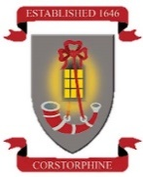
Digital Learning   | Learning and Teaching   |  |  | Inclusion   |  |  | 1+2  
- Digital Leads in each school  - Digital SWAY  - Digital Empowerment  - Sharing good practice  - Digital School’s Award | - Priority Writing  - Covid-Recovery Teacher  - Moderation  - Learning and Teaching Rep  - Associate HT  - Using SNSA data  - Sharing good practice |  |  | - Needs analysis  - Learning Spaces  - Health and Wellbeing Hub  - Moderation  - Sharing practice  - Educational Psychologist  - ASL  - CPMS – Transition  - Partnership Agencies  - School Counsellor  - Inclusion Board Rep  - Team around the Cluster (Pathway 3)  - Flexible Pathways |  |  | - Phrase of the fortnight  - Progression  - 1+2 Leads in each school  - Linguascope License

