Children will: Adults will:
Article 29
The right to a clean environment
Clean up after themselves

Keep the dining hall clean and tidy

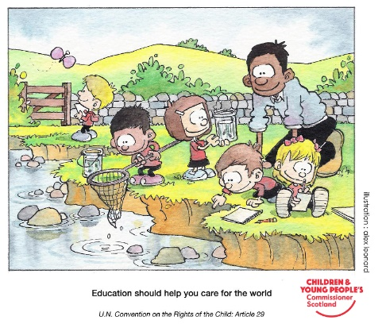

Try to reduce food waste

Be friendly

Recycle plastics and paper

Provide a balance of foods

Article 24 have the right to clean water and nutritious food.

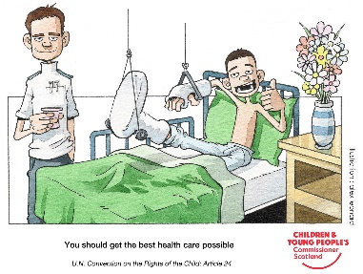
Try to eat a balance of foods

Do what is best for you

Article 3
Adults should do their best for you
Listen to adults

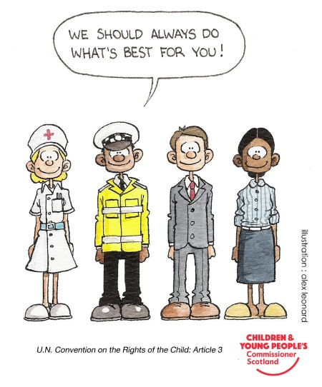
Be helpful

Be helpful

Listen when there is a problem

Use good manners

