Adults respect these rights by:
UNCRC Rights
Article 19
To be protected from hurt or harm
Children respect these rights by:
Article 31
To relax and play
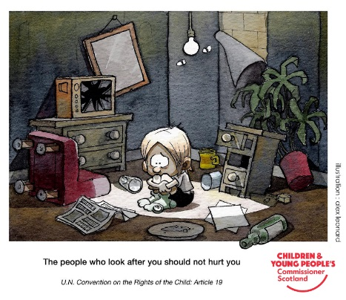
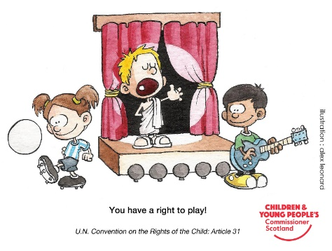
Help children make good choices, and make sure the school is a safe place
Having a growth mindset and trying our best

Being kind and letting others join in games
Make sure children are safe, and provide a good range of games and activities good choices, and make sure the school is a safe place.
Article 28
You have the right to an Education
Article 12
To be listened to and taken seriously

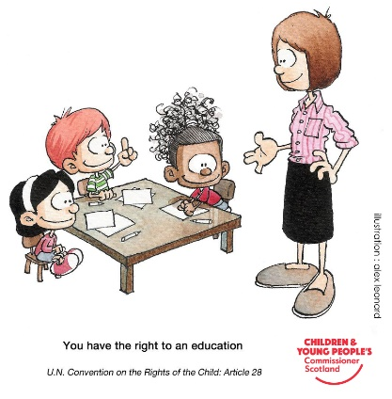
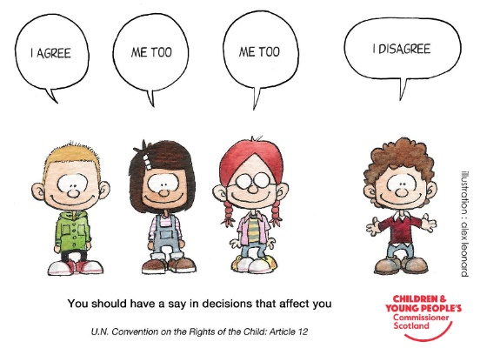
Making good choices and trying not to hurt others

Provide opportunities for children to be listened to

Listen to others and respect their opinion
Have high expectations for all children

