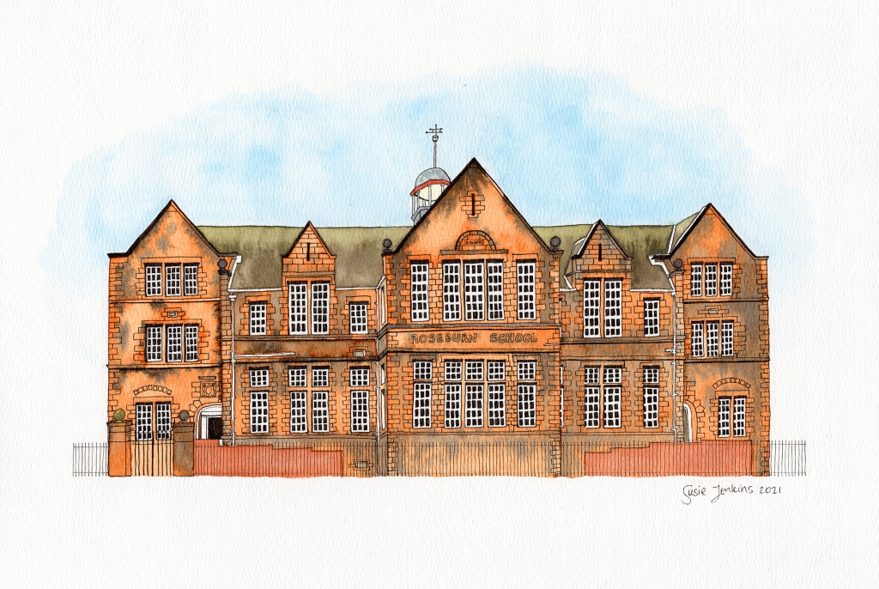
Learning Community Continue to develop high quality transition arrangements and develop the role of transition attainment team. Develop a shared vision for ASN and inclusion across the LC. Develop pathway provision. Collaborative professional learning for SLT & Curriculum Leads, and Early Years. Opportunities for learners to work collaboratively across LC.

Ethos & Life of the School Continue to embed our rights-based approach as a Gold Rights Respecting School. Further embed our whole school approach to HWB.

Outdoor Learning Provision of high-quality Outdoor Learning Experiences with a focus on literacy and numeracy.
Implement Playground Improvements

Empowered Learning Support high quality learning and teaching with a focus on digital learning and differentiation

Learning Teaching & Assessment Develop consistent approach to the teaching and learning of writing

Teachers Charter Continue to develop high quality learning and teaching through a focus on differentiation and progressive curriculum pathways

Equalities Continue to develop an inclusive school environment which promotes diversity and support for all learners
and develops a deeper understanding of everyone in our Craigmount community

Session 2022-23
Roseburn Primary School
School Improvement Plan

